GUIDELINES FOR INSTRUMENT CARE

COMPANY OVERVIEW
American Surgical Specialties Company is a medical device company focusing on a comprehensive line of premium, operating room grade general and specialty surgical instrumentation at industry-leading price points. The company also specializes in manufacture of hard-to- find, discontinued or custom instrument designs.

PRODUCT OVERVIEW
As an instrument-focused brand, Amerisurg Instruments offers among the industry’s most exhaustive selection of instruments across the full range of specialties, including: general surgery, plastic surgery/ent, obstetrics/gynecology, ophthalmology, orthopedics/neuro/spine, cardiothoracic surgery, laparoscopic/arthroscopic surgery, etc. Amerisurg Instruments is proud to offer its customers premium, operating room grade instruments forged from the highest quality German stainless steel. Amerisurg instruments are manufactured at the company’s network of ISO-certified facilities by experienced instrument craftsman to ensure all of the products it sells conform to the highest standards in instrumentation.

FORGINGS/STEEL
The most important factor in determining the durability and build-quality of an instrument is the material and process used to create the instrument forging, or the raw material from which all instruments are made. The quality of the raw forging (or blank) determines the ability of the instrument to withstand repeated use and sterilization without compromising its integrity or finish. The vast majority of Amerisurg instruments are made with 400- series and 300-series German or European stainless steel, which are composed of alloys of an iron ore base with a delicate balance of carbon and chromium. Carbon gives the forging the hardness necessary for surgical applications and the chromium content provides a stainless, anti- corrosive finish. Stainless steel alloy sheets are milled into instrument blanks which are forged, die-cast or molded into pieces of varying size and shape. The pieces are then treated with heat to achieve the requisite spring and temper, providing the flexibility to withstand the stresses of repeated use.
Depending on the instrument type, Amerisurg Instruments products are made with either 300 or 400 series grade stainless steel. The series of steel for an instrument depends on its intended use and desired malleability. Both of these steel grades are consistent with those used for premium, operating room quality instruments, which undergo repeated sterilization while resisting corrosion and maintaining strength.
Amerisurg offers operating room quality instruments, and on request can also supply an ‘economy’ or disposable line of products.

FINISH
Surgical instruments come in a variety of finishes. The vast majority of Amerisurg’s patterns come in a satin, sand- blasted or dull finish, which minimizes glare that may distract surgeons and hinder visibility under operating room lights. This is the standard finish of most instrumentation used in operating rooms today.
Certain instrument patterns are available and stocked in other finishes, including mirror (highly-polished), titanium (mostly microsurgical instruments) insulated (blue coated for electro-surgery) and ebonized (black coated for laser surgery). While all of these finishes can be sterilized in a similar fashion to stainless steel instruments, please pay attention to the particular guidelines for these finishes as outlined in this document.

OUR CRAFTSMEN
Much of our instrumentation is hand-finished by skilled craftsmen whose families have apprenticed in the art of instrument-making for generations. Working with such experienced craftsmen and established facilities ensures that our products conform to the highest quality standards. However, as with any process by hand, slight variations in dimension may occur between the actual product and the specifications listed in company literature or the website. Any such variation will be immaterial and never affect the intended functionality of an instrument.

STERILITY
Amerisurg instruments do not typically ship sterile, as is the case for most operating room quality instrumentation (aside from select items such as surgical blades, which always ship sterile). Typically, economy or “floor-grade” instruments are sold sterile, as they are either disposable or can only withstand autoclaving a couple times before their service life is over.
Since American Surgical Specialties Company’s instruments are supplied non-sterile, they must be cleaned, lubricated and sterilized prior to initial use.

PROPER CARE & MAINTENANCE
The single most important factor for maximizing the service life of a surgical instrument aside from the manufacturing material and process is proper and consistent care and maintenance.

ABOUT THIS GUIDE
Many healthcare facilities own tens or hundreds of thousands of dollars of surgical instrumentation. In order to maintain the value of that inventory and ensure optimal performance and safety of these devices in the operating room, instruments must be handled, cleaned and stored properly in a consistent maintenance program. Failure to do so may result in shortened lifespan and/or decreased efficacy of the device(s).
Amerisurg instruments are premium quality products that are intended to undergo repeated sterilization cycles, but their lifecycle depends on the meticulous execution of such a program.

This guide is meant to provide background information as to the handling, storage, cleaning, decontamination, and sterilization of most Amerisurg Instruments products. When combined with proper training and established industry reference books, this guide will allow you to extend the life of your devices while improving safety, performance and service life. The information in this guide is consistent with International Association of Healthcare Central Service Materiel Management (IAHCSMM) guidelines for the care of surgical instruments. This guide is not meant to be exhaustive; it is simply a quick reference guide that will allow you to easily find information on how to best care for your Amerisurg Instruments devices. Always use relevant reference manuals for more complete information. Failure to follow generally accepted instrument care and maintenance procedures will shorten the service life or instrumentation and may invalidate the manufacturer instrument warranty.

CONTACT US
If you have any questions or concerns regarding this guide or specific maintenance protocols, feel free to contact us using the information below:
American Surgical Specialties Company 475 Metroplex Dr. #401,
Nashville, TN 37211
Tel: 615-739-5351
www.americansurg.com

Email: sales@americansurg.com

INDICATIONS FOR USE
American Surgical Specialties Company surgical instruments are designed to perform a specific function, such as cutting, grasping, clamping, dissecting, probing, retracting, draining, aspirating, suturing, or ligating. For use by, or as directed by, a surgeon. Instruments should be used only for the purpose for which they are designed. The proper surgical technique for the use of instruments is the responsibility of the surgeon.

CONTRAINDICATION
Instruments should not be used for anything other than their intended use.

WARNING
Consult individual national infection control/prevention protocols for specific guidance regarding processing medical devices with suspected exposure to Creutzfeldt- Jakob Disease (CJD).

CAUTION
After cleaning, especially ultrasonic cleaning, check screws on instruments because the vibration from the ultrasonic cleaning may cause them to loosen or fall out. For electrosurgical instruments, use the least amount of power appropriate for the application. For electrosurgical cables, disconnect from the generator or instrument by grasping the connector only. Do not pull the cable by the cord. Do not use instrument or cable if insulation is not fully intact.
American Surgical Specialties Company surgical instruments are supplied non-sterile and must be cleaned, lubricated and sterilized prior to use according to hospital protocol and the procedures outlined in this document. Failure to follow these procedures will invalidate the instrument’s warranty and can cause the instrument to fail. Inappropriate use of instruments will lead to damage that is usually not repairable; for example, a hemostat that is used to clamp tubing can become misaligned and quickly break.

INSPECTION OF ALL INSTRUMENTS
All instruments are carefully inspected before shipment. Because damage may occur during transit, the instruments should be thoroughly inspected upon receipt. All instruments must be inspected prior to use.
Handling and Operating Instruments: Instruments should be handled and operated by personnel completely familiar with their use, assembly and disassembly. Before a new instrument is used and prior to each surgical procedure, the instrument must be decontaminated, lubricated and sterilized as described below. Handle the instrument with care. The instrument must be inspected to assure proper functioning prior to each use with particular attention paid to the condition of all moving parts, tips, box locks,

ratchets and cutting edges. Each instrument with a screw must be inspected before and after use to ensure that the screws do not move when operating the instrument. Screws can loosen and back out of an instrument as a result of normal operation and/or the vibration during ultrasonic cleaning. Failure to make a complete inspection to assure the proper operation and function of the instrument may result in unsatisfactory performance, perhaps because a part is missing. Do not use if the instrument does not appear to be functioning properly. Use of an instrument for a task other than that for which it is intended could result in a damaged or broken instrument, or one which provides an unsatisfactory performance. In order to insure warranties and guarantees, instruments in need of repair should be sent to American Surgical Specialties Company

DECONTAMINATION AND STERILIZATION PROCEDURES
As with any decontamination procedure, personnel should follow accepted guidelines for hand washing, the use of protective attire, etc. as recommended by A.A.M.I. Standards and Recommended Practice, “Safe Handling and Biological Decontamination of Medical Devices in Health Care Facilities and in Non-Clinical Settings”, ANSI/AAMI ST35:2003.
Decontamination is a two-step process:
- Thorough cleaning and rinsing.
- Sterilization or disinfection.

DECONTAMINATION
PRE-CLEANING: Remove gross debris from surgical instruments with a lap sponge and sterile water routinely during the procedure to prevent drying on of blood and body fluids, etc. It is important to rinse instruments that have been exposed to blood and saline solution before these substances dry. Blood and body fluids as well as saline solutions are highly corrosive. In addition, blood can produce a stain that is difficult to remove.

CLEANING: To prevent the formation of biofilm, cleaning should occur as soon as possible after instrumentation is used. Biofilm is an accumulation of a biomass of bacteria and extracellular material that tightly adheres itself to the surface of the instruments. It cannot be easily removed, and protects microorganisms from being easily removed by ordinary cleaning/decontamination methods used in hospitals. It is particularly problematic in lumened medical devices.
Step 1. Maintain moisture: Immediately after the surgical procedure, place the instruments in an instrument tray/container and cover with a towel moistened with sterile distilled water. Foam, spray or gel products, specifically
intended for use with surgical instruments, are available to keep the soil moist. Transport tray of soiled instruments in an impervious plastic bag or container with a tight lid to the decontamination environment (keep the outside of the containment clean).
Step 2. Enzymatic Soak: Immerse fully opened and/or disassembled instruments in an enzymatic solution, specific for use with surgical instruments. Prepare the solution and use per enzyme manufacturer’s recommendations, paying special attention to instructions for correct dilution, temperature and soak time. Flush air from lumens and fill them with enzymatic solution for full contact with this inner surface during the soak time.
Step 3. Rinse: Remove from enzymatic soak after the time period recommended by the enzymatic manufacturer and rinse thoroughly with tap water. Flush lumens until rinse water runs clear.
Step 4. Cleaning Instruments: Choose a cleaning solution appropriate for surgical instruments and follow the manufacturer’s instructions for use. The use of neutral pH detergents is vital to the maintenance of surgical instruments. Contact with acidic or alkaline solution will remove the instruments’ protective barrier of chromium oxide, often leading to corrosion, pitting, and breakage. You may find that depending on the type of soil, a detergent that is a little more or less acid or alkaline may be more appropriate. The ideal cleaning agent is nonabrasive, low-foaming and free-rinsing. Using a small clean hand- held brush, remove soil from all surfaces of the instrument while fully immersed in the solution. During manual cleaning, never use steel wool, wire brushes, scalpel blades or highly abrasive detergent or cleansers to remove soil from surgical instruments. These will damage the instruments’ protective surface and lead to corrosion. Use a clean soft bristled brush to clean instruments with an accessible channel. Remove the soil from the ratchets, jaws, tips, box locks, and/or hinge mechanism. The box lock and hinge portion of an instrument must be thoroughly cleaned after each use. A build-up of soil, debris, lubricants, etc. in these areas, will make it difficult to use the instrument and eventually irreparably damage it. Vigorously flush channels with the cleaning solution. Deionized water is recommended and preferred because it is free of the many compounds which exist in ordinary tap water. These substances, alone, cause stains and when tap water is combined with some detergents it will form insoluble deposits on the instruments. Manual cleaning should remove all visible residue. It is essential to keep the box locks and hinges open during any manual or automated cleaning process.

Manual Cleaning
It is possible, and in some cases necessary, to clean surgical instruments by hand. For delicate instruments, hand washing is likely required. Devices, especially those that are used in invasive operations such as orthopedic surgery, may need to be hand washed prior to machine-washing to remove the gross amounts of soil that may be contained within them. This is in addition to the rinsing and enzymatic soak required for all surgical instruments. Use manufacturer instructions and your best judgment to determine if a device requires hand washing prior to automatic cleaning. Manual cleaning should be used in most circumstances only as a secondary option.
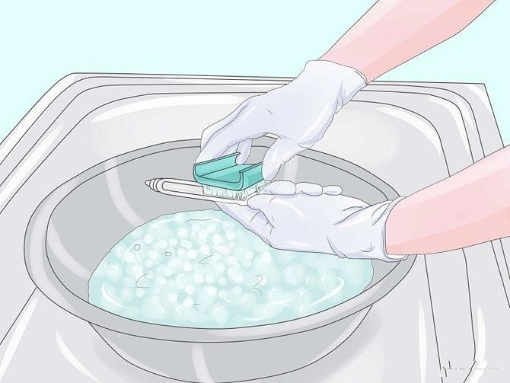
Follow the guidelines below when cleaning manually:
- Before hand washing an instrument, it is vital that you ensure your own safety. Soil and fluid proof goggles, gloves, aprons, and shoe covers should always be used.
- Check your equipment to make sure you are using a neutral (pH 7) detergent.
- Use distilled water for best results.
- Follow the detergent manufacturer’s instructions with regard to cleaning time, dilution, etc. Instruments should be fully submerged for the period of time recommended by the manufacturer of the cleaning product. Change solutions frequently, per the solution manufacturer’s recommendations.
- Carefully and diligently remove all soil from the instrument, paying special attention to hard to reach places such as box locks, instrument jaws and crevices. Instruments should be cleaned in the open (unlocked) position while ensuring sharp instruments don’t touch each other.
- Using a small, clean, soft-bristled hand-held brush, remove soil and organic material from all surfaces of the instrument while fully immersed in the solution. Brushes should be stiff but not abrasive. Never use abrasives like steel wool, and only specifically-designed wire brushes should be used on particular areas of the instrument (serrations, files, etc.).
- Remove the soil from the ratchets, jaws, tips, box locks, and/or hinge mechanisms. The box lock and hinge portion of an instrument must be thoroughly cleaned after each use.
- If applicable, vigorously flush device lumens, channels, and other areas that are not easily accessible with a brush.
- Thoroughly rinse devices and dry with clean, non- abrasive, soft towels laundered with neutral (pH 7) detergent.
- Inspect the device carefully to ensure that it maintains a free range of motion, tips are aligned, etc.
- Proceed to ultrasonic or automated machine-washing as appropriate.
Step 5. Rinse: Thoroughly rinse instruments by immersing in tap water and wiping with a clean, soft cloth. Flush lumens until water runs clear.
Step 6. Ultrasonic Cleaning and Rinsing: Amerisurg Instruments recommends the use of an ultrasonic cleaner as it is widely regarded as the most effective way to clean surgical instruments; in particular it is best for removing soil from hard to reach surfaces such as grooves, crevices, hinges, box locks, and other moving parts, etc.
Before using an ultrasonic cleaner, be sure to follow the manual cleaning procedures detailed above if applicable to remove any gross soil such as blood and tissue debris. This will help keep the ultrasonic solution clean.
Please follow these guidelines when using ultrasonic cleaners:
  - Use only detergents that have been specifically formulated for ultrasonic cleaners. These detergents should be pH-neutral and low-foaming to avoid inhibiting the cleaning process.
Follow the recommendations of the ultrasonic manufacturer regarding cycle times, detergents, proper placement of the instrument tray, and conditioning (“degassing”) of the cleaning solution, etc. Use an ultrasonic cleaner to remove soil from hard to reach surfaces such as grooves, crevices, lumens, instruments with moving parts, etc., after gross soil has been removed. Open or disassemble instruments as appropriate. Place instruments in a mesh bottom stainless steel instrument tray. Place the tray into the ultrasonic cleaner. Flush air out of lumens and fill them with the ultrasonic cleaning solution (under the solution level in the chamber) for effective removal of soil from that inner surface by the ultrasonic activity.
Use distilled water for best results.
Bath temperatures for cleaning instruments should be between 27°C (80°F) and 43°C (109°F). Follow sterilization equipment and solution manufacturer’s recommendations for temperature and cycle time, but note that temperatures above 60°C (140°F) will coagulate protein and make it more difficult to remove.
Ultrasonic solution should be changed when it is visibly soiled, or at regularly scheduled intervals to prevent the redeposit of soiled particles onto other instruments, per solution manufacturer recommendations. Solution should be changed more frequently when cleaning devices that might have fatty deposits on them, such as orthopedic

instruments. When solution is changed, the tank should be cleaned and the drain checked for debris.
After solution is changed, the solution must be “degassed.” To degas the solution, close the lid and run the cleaner for 5-10 minutes without any devices in it. This will remove excess bubbles in the solution that may have arisen from the filling process.
All instruments must be completely submerged in order to ensure cleaning is effective.
Instruments placed in the ultrasonic cleaner should be in the open or unlocked position. Open or disassemble them as necessary. All instruments should be placed in trays designed specifically for use in the cleaner.
Separate dissimilar metal instruments during cleaning.
Do not let sharp instruments touch each other during cleaning.
All instruments in an ultrasonic cleaner should be of the same type of metal. Most Amerisurg Instruments are made of stainless steel, while some are comprised of titanium.
Note: Stainless steel and titanium or titanium nitride (ceramic coated) instruments have the same cleaning/sterilization instructions, but detergents/cleaners used should be formulated for each specific metal and only like metals should be cleaned/autoclaved together.
Follow all manufacturer instructions for care and use of ultrasonic cleaners.
Step 7. FINAL RINSE should be with “treated water”. Softened or deionized water should be used for the final rinse to better remove detergents etc. Softening water removes calcium and magnesium ions that cause water to be hard. Iron ions may also be removed by this treatment. Deionization removes ionized salts and particles from the water. Excessively hard water can spot or stain instruments and excessive chlorine in water can cause pitting of the instrument. Deionized water is preferred for the final rinse.
Step 8. Decontaminate Clean Instruments: Once instruments have been cleaned they must be rendered safe for handling, inspection and assembly. They may be steam sterilized without a wrapper or disinfected following the instructions from the instrument, sterilizer and disinfectant manufacturers.
Step 9. Visual Inspection and Instrument Set Assembly: Visually inspect the instrument for cleanliness and to ensure all parts are in proper working order, as the set is assembled. Inspection is a vital part of proper care and maintenance. Instruments in need of repair will not perform accurately in surgery and breakage is likely to occur. DO NOT USE damaged instruments. Worn ratchets, loose box locks and misaligned jaws can be repaired at a fraction of the cost of new instruments. Contact your local representative for information regarding a cost-effective instrument repair program.
Step 10. Lubricate: The use of an instrument lubricant, that is compatible with the method of sterilization to be used, is recommended before instruments are sterilized. Be certain that the instrument lubricant is diluted and maintained properly, according to the manufacturer’s instructions. This type of lubricant is referred to as “instrument milk” and is usually applied by spraying into the box locks and moving parts or by dipping the opened instruments into a solution. Lubricants that are too concentrated or too heavily applied will result in slippery instruments that will also be mistaken as wet after sterilization. After thoroughly cleaning instruments, proper application of lubricants to joints will keep them moving freely and aid in protecting the surface from mineral deposits. Note that ultrasonic cleaners remove all lubrication; therefore this maintenance procedure should be done routinely after ultrasonic cleaning and before sterilization. Proper lubrication is a vital step in maintaining the long-life of the surgical instrument. Lubrication will prevent the friction of metal on metal and preserve the smooth function of the instrument thus avoiding corrosion by friction. Furthermore, routine use of lubricating agents, on thoroughly clean instruments, will prevent hinged and other movable parts from sticking. Lubrication will aid in protecting the entire instrument surface from mineral deposits.
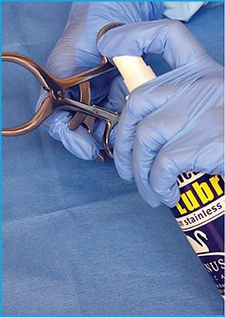

Step 11. Drying: Before instruments are wrapped for sterilization or storage, they must be thoroughly dry. If a set of instruments is wet when wrapped for sterilization it is likely to come out of the sterilizer wet. “Wet Packs” are not suitable for use after sterilization because they may be easily contaminated when handled. In addition, remaining moisture, particularly in box locks and hinges may result in corrosion that will weaken the instrument and lead to

breakage during use. Prepare instrument sets for sterilization using a wrapper, pouch or rigid sterilization container that is appropriate for the method of sterilization to be used. The Association for the Advancement of Medical Instrumentation (AAMI) and individual sterilizer manufacturers provides guidance for the proper preparation of surgical instrument trays for sterilization. Some sterilizer manufacturers can also provide information regarding wet pack problem solving. See also, Sterilization for the Healthcare Facility, 2nd Edition, Reichert, M.; Young, J., “Wet Pack Problem Solving”, Lee, S. (Frederick, MD: Aspen, 1997).

AUTOMATED MECHANICAL DECONTAMINATION
General surgical instrumentation may be processed in a washer sterilizer or washer decontaminator/disinfector. Some of these processes include an enzyme application phase and a lubrication phase that is designed into the cycle.
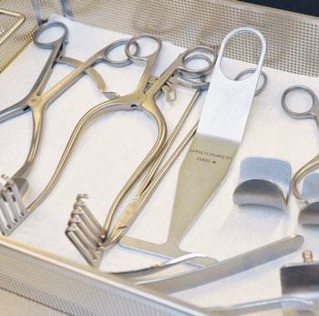

Follow the manufacturer’s specifications when using automatic washer-sterilizers or washer decontaminators/disinfectors. They usually require the use of a low foaming, free rinsing detergent with a neutral pH (7.0). A high-foaming detergent may clean effectively but will often leave residual deposits on the instruments and do harm to mechanical washers. Automated washer sterilizers and washer decontaminator/ disinfectors usually have adjustable wash and rinse times. Some washers enable the user to customize extra cycles to process heavily soiled surgical instruments more effectively. These devices work on the principle of impingement, or pressure removing soil from a surface similar to a dishwasher. They are also effective because of their ability to use thermal and
enzymatic detergents. Please follow the guidelines below when using automated mechanical washers:

- Before using an automated washer, ensure that racks are not overloaded and that all spray arms can move freely. If instruments are sticking up or are out of their baskets, they must be relocated so as to be out of spray arm paths. Failure to do so could result in damage to the washer, the instruments, or both.
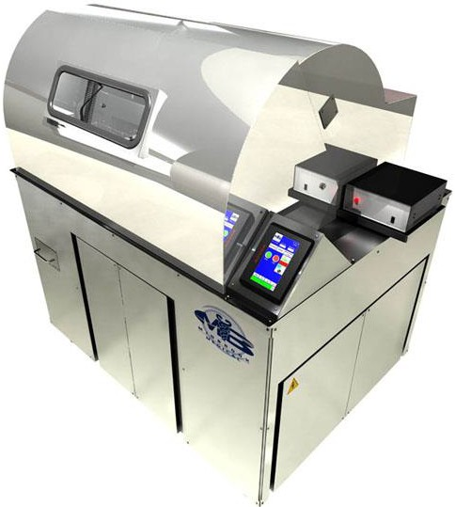
- Wash like metals together to ensure that there are no adverse effects of machine washing. In general, Amerisurg Instruments are stainless steel but some include titanium.
- As with all cleaning methods, ensure that devices are in the open position and they are spaced such that water can reach all parts of the device. Multi-rack storage trays might need to be disassembled to facilitate cleaning.

- Inspect the racks, trays and especially the washer traps/drains to ensure they are in good working condition and free of debris.

- Ensure that detergent/lubricant is sufficient prior to beginning the cycle, per the sterilization equipment manufacturer’s recommendations.

- When selecting a wash cycle for mixed-use loads, the most extensive applicable cycle must be used. The most extensive cycle is generally for surgical instruments. If even one surgical instrument is being included in a load, the surgical instrument cycle must be selected.
- Follow the manufacturer instructions for your particular washer and select the appropriate cycle.

TERMINAL STERILIZATION
After following the decontamination recommendations, reusable instruments are ready for sterilization.

Independent laboratory testing, conducted according to the
F.D.A. (21 CFR PART 58) and Good Laboratory Practice Regulations (G.L.P.), has validated steam sterilization as an effective process for reusable instruments. See also, AAMI Standards and Recommended Practices, “Steam Sterilization and Sterility Assurance in Health Care Facilities”, ANSI/AAMI ST46:2002; “Flash Sterilization Steam Sterilization of Patient Care Items for Immediate Use, ANSI/AAMI ST37:3ed. AAMI standards recommend that the sterilizer manufacturer’s written instructions for cycle parameters should also be followed. Steam sterilization of lumened instruments requires that they be flushed with sterile water just prior to wrapping and sterilization. The water generates steam within the lumen to move air out. Air is the greatest enemy to steam sterilization, preventing steam contact if not eliminated. Medical device manufacturer’s exposure times to sterilization temperature may need to be longer than the minimum indicated by the sterilizer manufacturer but must never be shorter. Recommended sterilization parameters are as below: (Ref: IAHCSMM CST Manual Table 15.20)

Gravity Air Displacement
Item | Exposure Time |  |  | Drying Time
Item | @ 250º F  (121º C) | @ 270º F  (132º C) | @ 275º F  (135º C) | Drying Time
Wrapped Instruments | 30  Minutes | 15  Minutes |  | 15-30  Minutes
Wrapped Instruments |  |  | 10  Minutes | 30  Minutes
Textile Packs | 30  Minutes | 15  Minutes |  | 15-30  Minutes
Textile Packs |  |  | 10  Minutes | 30  Minutes
Wrapped Utensils | 30  Minutes | 15  Minutes |  | 15-30  Minutes
Wrapped Utensils |  |  | 10  Minutes | 30  Minutes
Unwrapped Nonporous Items (e.g. Instruments)  (Flash Cycle) |  | 3 Minute | 3 Minute | 0-1  Minute
Unwrapped Nonporous & Porous Items in Mixed Load  (Flash Cycle) |  | 10  Minute | 10  Minute | 0-1  Minute
There are two types of sterilization: high and low temperature. This guide will deal mainly with high temperature sterilization, as that is what Amerisurg Instruments recommends for almost all of its products. However, some items such as endoscopes and plastics are not suitable for high temperature sterilization. In this case, low temperature chemical sterilization may be used.
The efficacy of both types of sterilization is affected by several factors:
    - The type and number of microorganisms present
    - The amount of soil present
    - The amount of protection the medical device provides, such as box locks or tubes

Cleaning and disinfection as outlined earlier in this document can dramatically mitigate these factors and make sterilization much more effective.
If devices were sterilized in individual or group sterilization packs, they must be kept in these packs for storage.
Before instruments are wrapped for sterilization, they must be thoroughly dried. Wet instruments wrapped for sterilization are likely to come out of the sterilizer wet and prone to contamination. Moisture, particularly in box locks and hinges, may result in corrosion that will weaken the instrument and lead to breakage.

LUBRICATION
Some automatic washer sterilizers include a lubrication phase that is built into the cycle – if not; ensure instruments are lubricated per the guidelines below prior to sterilization. An instrument lubricant (often referred to as instrument milk) that is compatible with the method of sterilization to be used is recommended before instruments are sterilized. Ultrasonic cleaners remove all agents. Thus, instruments cleaned with an ultrasonic cleaner must be lubricated routinely after cleaning and before sterilization.
Some lubricants must be diluted in a solution and used by dipping instruments in the open position, while others may be applied directly into box locks, hinges and other moving parts. Follow the manufacturer’s instructions for proper use.
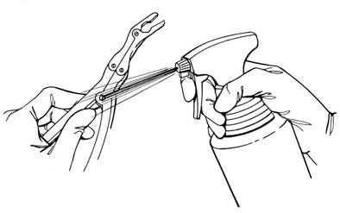
Proper application of lubricants to joints will keep them moving freely and aid in protecting the entire instrument surface from mineral deposits. Lubrication will prevent metal-on-metal friction, sticking and corrosion, as well as preserve the smooth function of the instrument.

HIGH-TEMPERATURE STERILIZATION
There are two types of high temperature sterilization: flash and terminal. Flash sterilization occurs when sterilizing an item that is not packaged, usually in an emergency situation in the operating room. Terminal sterilization means the item is packaged. Central service departments generally perform terminal sterilization, which is more extensively

covered here since it is the preferred method for American Surgical Specialties Company’s instruments.

These procedures are approved for stainless steel, titanium, tungsten carbide, bipolar, nylon-coated, and fiber optic instruments unless otherwise stated. However, nylon coated instruments should not be flash sterilized.
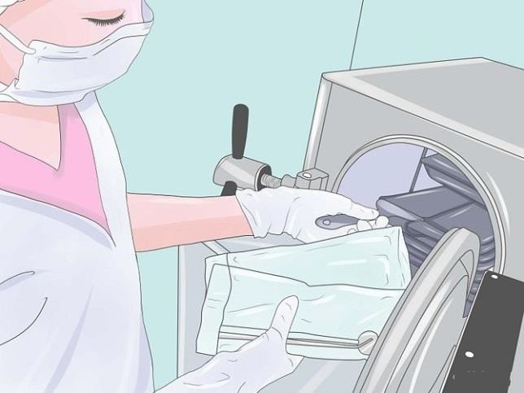
High temperature sterilization is the process of sterilization by using high temperature and pressure steam to kill all microorganisms on a device. Steam is used as it is a much more effective conductor of heat than air. There are several types of steam sterilizers:

- Table top sterilizers use gravity air displacement and are generally used in smaller clinics
- Gravity air displacement sterilizers are small-to- medium size and use the density difference between air and steam to create a pressurized, steam-only environment
- Dynamic air removal sterilizers have vacuum pumps that are used to remove air, ensuring only steam is extant in the sterilization chamber. These devices have a faster sterilization cycle than gravity air displacement machines.
- Steam-flush pressure-pulse sterilizers use a repeated sequence of steam flush and pressure pulse to remove air from the sterilization chamber. This type of sterilizer is not susceptible to air leaks like dynamic air removal machines.
- Special purpose pressure (flash) sterilizers are used for emergency sterilization of dropped instruments when there is not time for regular sterilization

It is vital to understand which sterilizer is being used to ensure correct cycle times. The subsequent steps outline the process:
- As noted previously, before any sterilization process, instruments must be lubricated. Use an approved lubrication agent such as instrument milk. Never use an industrial lubricant such as WD40. Lubricant should not be wiped off instruments prior to autoclaving.
- Check the autoclave to ensure that it is working correctly.
  - Cool the chamber before performing any maintenance
  - Perform Bowie-Dick tests
  - Perform routine cleaning
  - Check the steam sterilizer and door gasket
  - Follow any other of the sterilization manufacturer instructions to ensure that the autoclave is working properly
  - Ensure autoclave filters and chambers are cleaned regularly
  - Document the results of these tests
- Place the items in the autoclave either as a group or individually
  - Individual items should be placed in disposable paper or plastic pouches. Make sure that the pouch is large enough for the device to be in the open position. Ensure that the pouch is appropriately sealed, but steam permeable.
  - Instrument sets can be placed together in specially designed trays with holes to allow for steam or in fabric pouches. Do not hold devices together with rubber bands.
  - Items such as basins that are capable of capturing condensate should be placed on edge so they may drain.
  - Make sure all devices are in the open or unlocked position.
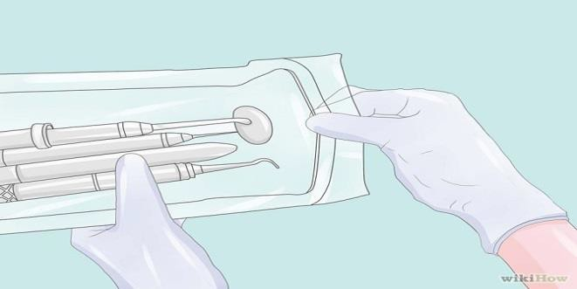

- It is vital that each part of each instrument be in contact with the sterilization agent (steam). This means that all devices must be open, disassembled, and cannot be placed too close together. Close placement could create pockets where steam cannot fully penetrate. In addition, devices cannot be placed in containers that steam cannot penetrate. All sterilization pouches will allow the penetration of steam.
- Ensure that the autoclave trays/shelves are not overloaded. This could cause pockets where steam cannot fully penetrate.

- If any fabric is being used for wrapping of instruments, ensure that it is being laundered with neutral (pH 7) detergent as it could otherwise cause damage.
- Following manufacturer instructions begin the sterilization cycle. Amerisurg Instruments recommends the following exposure times based on temperature and autoclave type:
Dynamic Air Removal ( e.g. Prevacuum)
Item | Exposure Time |  | Drying Time
Item | @ 270º F (132º C) | @ 275º F (135º C) | Drying Time
Wrapped Instruments | 4 Minutes |  | 20-30 Minutes
Wrapped Instruments |  | 3 Minutes | 16 Minutes
Textile Packs | 4 Minutes |  | 5-20 Minutes
Textile Packs |  | 3 Minutes | 3 Minutes
Wrapped Utensils | 4 Minutes |  | 20 Minutes
Wrapped Utensils |  | 3 Minutes | 16 Minutes
Unwrapped Nonporous Items (e.g. Instruments)  (Flash Cycle) | 3 Minute | 3 Minute | N/A
Unwrapped Nonporous & Porous Items in Mixed Load  (Flash Cycle) | 3 Minute | 3 Minute | N/A
(Ref: IAHCSMM CST Manual, Page 299, Table 15.21)

- During the autoclave process, check the pressure and temperature gauges on the autoclave and compare them to a steam table (located on the autoclave or in reference books) to ensure that steam saturation is occurring. If it is not, consult a qualified repair technician to ensure that the device returns to working order. Sterilizations performed by an autoclave not reaching steam saturation are likely not complete.
- After the cleaning and rinsing cycles are complete, but before the drying cycle begins, open the door of the autoclave about ¾ of an inch, and then run the dry cycle, or per manufacturer instructions. Do not open the door fully before the dry cycle as this can result in wet packs.
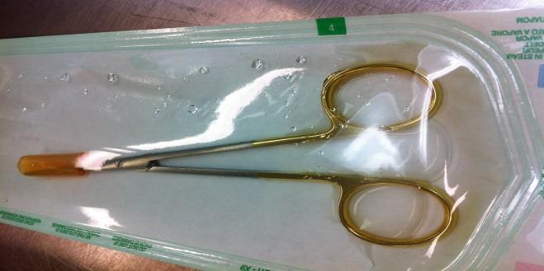
- After the dry cycle is complete, carefully inspect the devices for any wet packs. Wet packs are surgical devices
or packs that have condensation inside or outside of them. Wet packs are considered contaminated and must be completely reprocessed. Do not touch the devices.
- Inspect the devices, looking at any indicators or packs used to ensure that proper sterilization took place. Chemical indicators should clearly change color/shape/size, etc., to show that the proper temperature was reached.
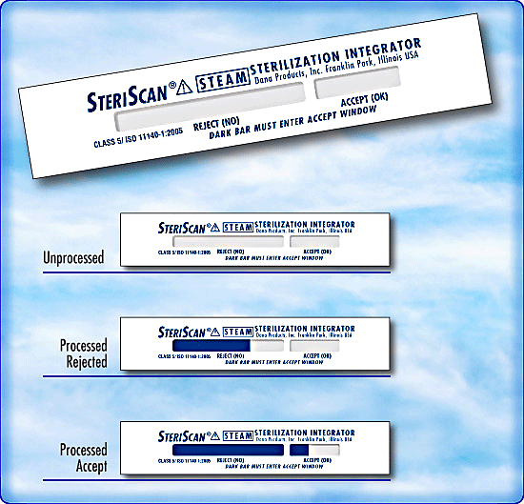

- Do not handle the devices any more than is required. Any moisture on a sterile instrument pack means that it could be contaminated. Packs only provide adequate barriers against contamination when dry.
- After devices are removed and stored securely and sterilely, perform routine maintenance and cleaning on the autoclave, including clearing out the steam drain to ensure it is ready for the next use. Always wait until the autoclave has cooled to perform maintenance or cleaning procedures.

Some healthcare facilities are located at much higher elevations (e.g. Denver ,CO is one mile above sea level) The following Table shows the gauge pressure needed to saturate the steam at an altitude of one mile for various operating temperatures:
Temperature |  | Absolute Pressure | Gauge Pressure (Lbs/in²)
ºF | ºC | (psia) | Sea Level | One Mile Altitude
212 | 100 | 14.696 | 0 | 2.7
220 | 104 | 17.186 | 2.5 | 5
225 | 107 | 18.912 | 4 | 7
230 | 110 | 20.779 | 6 | 9
235 | 113 | 22.800 | 8 | 11
140 | 115.5 | 24.968 | 10 | 13
245 | 118 | 27.312 | 13 | 15
250 | 121 | 29.825 | 15 | 18

255 | 125 | 32.532 | 18 | 20.5
260 | 127 | 35.427 | 21 | 23
265 | 129 | 38.537 | 24 | 26.5
270 | 132 | 41.856 | 27 | 30
275 | 135 | 45.426 | 31 | 33
280 | 138 | 49.200 | 35 | 37
285 | 140.5 | 53.249 | 39 | 41
(Ref: IAHCSMM CST Manual, Page 300, Table 15.22)

LOW TEMPERATURE STERILIZATION
Low temperature sterilization is the process of using low temperature gases or liquids in order to sterilize instruments. In this way, it is similar to disinfection. However, it is important to remember that sterilization means that all organisms have been killed. For this reason, an instrument is only considered sterile by chemical means after it has been submerged (in gas or liquid) for 10 hours. The harsh chemicals and long exposure times are often corrosive to surgical instruments. For this reason, Amerisurg Instruments recommends high temperature sterilization for its products. Low temperature sterilization, however, may be suitable for some products which cannot be autoclaved, including some endoscopes or plastic constructions.
These devices must be sterilized through low temperature means. In some cases, high-level disinfection may even be sufficient.

For endoscopes, proceed with the cleaning steps as described above but do not use ultrasonic cleaners or automated washers, as these can damage the scopes. Instead, hand wash only and use enzymatic cleaners as prescribed by the manufacturer. Do not allow the endoscope to soak for more than 30 minutes in any solution, as moisture can damage it.
In order to use chemical sterilizers, follow a procedure similar to disinfection. Based on the device being used, choose an effective sterilizer and follow the manufacturer instructions. For endoscopes, ethylene oxide sterilization is recommended.
When performing ethylene oxide sterilizations, the endoscope must be completely dry in order to prevent the formation of a harmful byproduct. Temperatures should stay below 60°C (140°F) and pressure below 22 psi.
Note: Do not use solutions containing benzyl aluminum chloride when sterilizing instruments with tungsten carbide inserts, as this will cause irreparable damage. Amerisurg Instruments recommends high temperature sterilization for these instruments.

STORAGE
- Surgical instruments should be stored only once they are decontaminated, sterilized and lubricated. General procedures for decontamination and sterilization are given above. Always consult reference manuals for complete instructions.
- Instruments should be lubricated using a neutral (pH 7) lubricant such as instrument milk. Regular lubrication helps keep the instruments protected and can prevent corrosion by creating a protective layer in a process known as passivation. Some lubricants are concentrated and require dilution before they can be used. Read the lubricant manufacturer instructions to know how to best use the lubricant.
- It is important that surgical instruments are never stacked or piled together. This can cause damage to delicate instruments and can reduce their efficacy. Surgical instruments should be stored by carefully placing them individually in a storage container.
- Surgical instruments should be stored in a clearly marked location such as a drawer or cabinet. This location should be kept clean. Ideally this area is kept secure and is out of the way from general workflow. It is essential that this space be kept dry to prevent contamination or water spots. Silica gel packets or other drying agents should be used to keep the area dry.
- Surgical instruments should be stored using products such as roll packs. This prevents the instruments from touching one another, which could cause damage. It is inadvisable to keep instruments in a drawer without any protection. It is vital that sterile instruments be stored in their sterilization packs.
- Sterile instruments should be stored using a first-in, first-out (FIFO) system. This means that older instruments that have been in storage longer should be removed first. This will help prevent contamination.
- Devices should always be stored with their protective tip/edge coverings (where appropriate). These coverings can prevent the instrument from becoming dull and also reduce the risk of injury while handling
Note: Handling and storing devices with fiber optic cables should be approached extremely delicately. At no point should the cable be bent, kinked, distorted, etc. No heavy or sharp items should be placed on top of or near these cables. The lenses are extremely fragile and must be treated with care. Wipe only with soft gauze to prevent scratching. Never pull or yank on the cables.

GENERAL HANDLING & INSPECTION
- American Surgical Specialties Company’s instruments are designed for use and handling only by those with the proper training and certification to do so. Surgical instruments can be fragile and dangerous, and as such should be treated with the utmost care and attention. Anyone who handles surgical instruments must be familiar with their use, assembly, disassembly, and all the risks associated with each device. Any information in this guide should be used only by qualified personnel.

- Before and after each use, devices must be thoroughly inspected by a trained and certified technician. The device should be inspected to make sure that (when applicable) its tips are aligned, there are no pits, scratches or scrapes, the device has its full range of motion, there is no soil present, no screws are loose or can become loose during motion, the device is lubricated/disinfected/sterilized, all parts are present, and everything else is in order. Pay particular attention to the following when inspecting instruments: o Smooth instrument motion
  - Condition of moving parts, including tips, box locks, ratchets and cutting edges
  - Blade sharpness and cutting ability
  - Box lock and ratchet security
  - Security of screws during instrument operation
  - Tip and/or jaw alignment
  - Meshing of serrations and/or teeth, w/ no catching
  - Missing parts of obvious signs of wear
  - ​
- Under no circumstances should an instrument identified to be functioning improperly be returned to service prior to repair.
- It is important to ensure that one does not injure oneself when handling surgical instruments. Due to the nature of surgical instruments, they are likely to have sharp or otherwise dangerous edges and points. Combined with the possible presence of dangerous biological material, the utmost precaution must be taken when handling these devices. Most surgical devices have tip or edge protectors that blunt edges and prevent injury. Whenever possible (i.e. when both the device and its protector are sterilized) these protectors should be used. The proper use of these protectors will help prevent injury from handling as well as prolong the lifetime of the devices.
- Whenever one is handling a surgical device, proper personal precautions must be taken. These include wearing fluid resistant surgical gloves, aprons, goggles, shoe covers and masks as appropriate. These items will help prevent both physical injuries and biological hazards. Workers handling surgical equipment should wash their hands/arms and any other body parts that may come in contact with surgical devices frequently and thoroughly. Food and drink should not be allowed in the same areas as surgical equipment.
- Sterile instrument packs should not be handled excessively. Any touching, moving, or contact with the packs should be avoided if possible. Sterile instrument packs should be transported only on carts with solid bottom construction and should never be cradled.
- Immediately after surgical devices are used in an operation, they should be transferred to a tray with towels moistened by sterile distilled water to maintain moisture. As soon as is possible, they should be transferred to an enzymatic bath to soak. These steps will
aid in the cleaning process. Follow all instructions provided with enzymatic detergents.
- Some general handling guidelines include:
  - Avoid overloading of trays
  - Protect all sharp tips with tip protectors
  - All instruments should be air-dried prior to storing
  - Place heavier instruments on the bottom of trays
  - Store in a clean and dry environment

MAINTENANCE PROCEDURES
Improper, ineffective, and insufficient maintenance can greatly reduce the life of an instrument and will invalidate the instrument’s warranty. We cannot make any statement about how long an instrument will last. Designed and crafted to exacting specifications, instruments will perform for a reasonable number of years when the following steps are observed:
Protect Instruments: The most effective method of dealing with instrument problems is to prevent them from occurring. The use of “treated water”, careful preliminary cleaning, the use of neutralized pH solutions, adherence to manufacturer’s instructions, and visual inspection, will help to keep instruments performing accurately and cosmetically free of troublesome stains. It is important to act quickly should a problem arise. Delay will compound the problem and irreparable harm may result.
- Certain compounds are highly corrosive to stainless steel and will cause serious damage despite the passivated protective surface. If instruments are inadvertently exposed to any of the following substances, they should be rinsed immediately with copious amounts of water.
Instruments should never be exposed to:
Aqua regia Iodine
Ferric chloride Sulfuric acid Hydrochloric acid

The following substances should be avoided whenever possible:
Aluminum chloride Mercury chloride
Barium chloride Potassium permanganate Bichloride of mercury Potassium thiocyanate Calcium chloride Saline
Carbolic acid Sodium hypochlorite
Chlorinated lime Stannous chloride Dakin’s solution
- Any kind of corrosion will lead to rust on steel. Because rust particles can be transferred from one instrument to another, corroding instruments should be removed from service to prevent the formation of rust on other instruments.

- Instruments must be sterilized in the open position or disassembled as appropriate. Steam will only sterilize the surface it can directly touch.
- Every effort should be made to protect sharp cutting edges and fine working tips during all maintenance procedures. Avoid loading retractors and other heavy items on top of delicate and hollow instruments.

COMMON ISSUES
This section will allow you to diagnose possible issues with your instruments and take steps toward troubleshooting.

Wet packs: A wet pack is one that has water condensation after the high temperature sterilization process is complete. Wet packs are considered contaminated because water can allow for the transfer of contaminants that air can’t. Wet packs are most often the cause of improper loading of the autoclave. Either not enough room was allowed between packs, basin-like items were not tilted to allow for draining, or insufficient time was allowed for drying. Moisture inside a pack is indicative of improper positioning of devices that allowed steam to be trapped.

Diagnosing Spots and Stains: It is common for instruments to become stained or spotted despite the best efforts of the manufacturers and the hospital staff. In nearly all cases these problems are the result of minerals deposited upon the surfaces of the instruments, as well as insufficient cleaning. Adhering to proper technique during cleaning and sterilizing procedures will prevent most staining occurrences. However, they will sometimes arise very suddenly and will not disappear on their own. The following identifies some of the various instrument-related problems hospitals may encounter.

Brown Stains: Detergents containing polyphosphates may dissolve copper elements in the sterilizer. This results in copper being deposited on the instruments by an electrolytic reaction. The hospital may try a different detergent or check the quantities used. Usually a dull blue or brown stain is simply a build-up of oxidation on the surface. This film is harmless and will actually protect the instrument from serious corrosion.

Blue Stains: Blue stains are usually the result of cold sterilization techniques. It is important to prepare the solution according to exact proportions and to change the solution when recommended. Serious corrosion may occur if the solution is used beyond the manufacturer’s specified time limit. The use of distilled water and a rust inhibitor in the solution will help retard discoloration.

Black Stains: Black stains may be the result of contact with ammonia. Many cleaning compounds contain
ammonia and it will remain on the instruments unless they are well rinsed.

Light or Dark Spots: Spots are often the result of condensation pooling and then drying on flat and concave instrument surfaces. The mineral content of the water remains on the instrument. Using “treated water” as the FINAL rinse will help to remove the minerals found in water that can cause these residual spots. It is also important to follow the sterilizer manufacturer’s instructions for preparing instrument sets for sterilization. Standing instruments that have flat and concave surfaces “on edge” will enable the condensate to drain off and more readily dry, usually without spotting. An additional cause of spotting can be traced to the instrument wraps. During laundering procedures, it is vital that detergents are thoroughly rinsed out, and that the final rinse is prepared so that the wraps have a pH between 6.8 and 7.0. In addition, healthcare professionals should check the cleanliness of the sterilizer chamber. Steam can lift soil and poorly rinsed chamber cleaning detergents from the chamber walls and deposit them onto instruments and wrappers.

Rust Deposits: It is very unlikely for surgical grade steel to rust. What appears to be rust is often residual organic matter in box locks or mineral deposits which have been baked onto the surface of the instrument. In localities where the water has high iron content, for example, an iron deposit will result in a metallic film on the instrument. This may be prevented with the use of “treated water” for the FINAL rinse during cleaning procedures. The most effective method of dealing with instrument problems is to prevent them from occurring. The use of “treated water”, careful preliminary cleaning, using neutralized pH solutions, following manufacturer’s instructions, and visual inspection, will help to keep instruments performing accurately and cosmetically free of troublesome stains. It is important to act quickly should a problem arise. Delay will compound the problem and irreparable harm may result.

WARRANTY
Proper use of these procedures by trained personnel will go a long way towards the extending the useful life of your instruments.

AMERISURG INSTRUMENTS WARRANTY
American Surgical Specialties Company’s instruments are unconditionally guaranteed to be free of any defects in materials and/or workmanship when used under normal conditions for their intended surgical purpose. Any Amerisurg Instruments instrument that is determined to be defective will, at American Surgical Specialties Company’s discretion, be repaired or replaced at no charge. Normal wear and tear and/or instrument misuse, including improper

use or inadequate maintenance, are not covered under the manufacturer’s warranty. All American Surgical Specialties Company’s instruments are warranted only to the original purchaser.
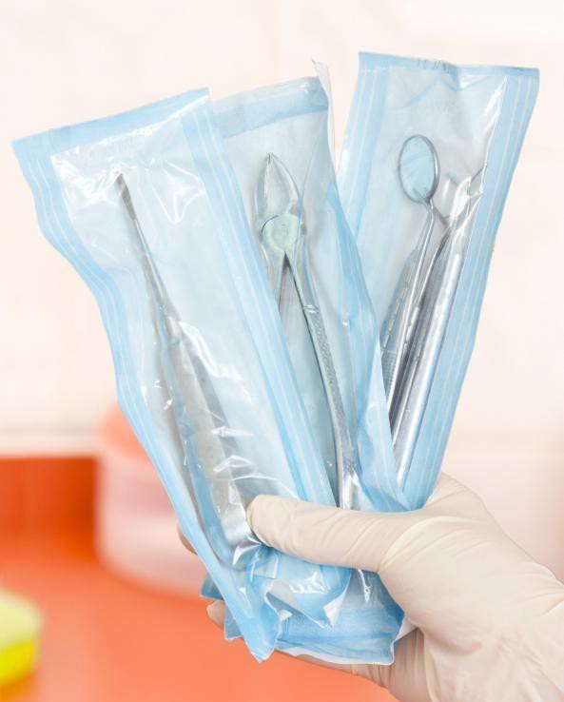
Much of our instrumentation is hand-ﬁnished by skilled craftsmen. As such, slight variations in dimension may occur between the actual product and the speciﬁcations contained herein.
The limited warranty described herein is the only warranty made by Amerisurg Instruments. Amerisurg Instruments makes no other representations, either expressly or implied, beyond the information contained here. Amerisurg Instruments disclaims any implied warranty of merchantability or ﬁtness for a particular purpose. Amerisurg Instruments will not be liable for any incidental, special, consequential or exemplary damages or loss of proﬁts in connection with the use of a Amerisurg Instruments instrument or product. The stated warranty is in lieu of all liabilities or obligations of Amerisurg Instruments arising out of or in connection with the delivery, use or performance of any Amerisurg Instruments instrument. Replacement or repair shall be the sole remedy for all breaches of all warranties and claims.

HANDLING
All surgical instruments must be handled with the greatest care when being transported, cleaned, treated, sterilized and stored. This is especially true for blades, fine points and other sensitive areas. Surgical instruments corrode and their functions are impaired if they come into contact with aggressive materials. The instruments must not be exposed to acids or other aggressive cleaning agents.

PRODUCT INFORMATION DISCLOSURE
AMERICAN SURGICAL SPECIALTIES COMPANY AND MANUFACTURER EXCLUDE ALL WARRANTIES, WHETHER EXPRESSED OR IMPLIED, INCLUDING BUT NOT LIMITED TO, ANY IMPLIED WARRANTIES OF MERCHANTABILITY OR FITNESS FOR A PARTICULAR PURPOSE. NEITHER AMERICAN SURGICAL SPECIALTIES COMPANY NOR MANUFACTURER SHALL BE LIABLE FOR ANY INCIDENTAL OR CONSEQUENTIAL LOSS, DAMAGE, OR EXPENSE, DIRECTLY OR INDIRECTLY ARISING FROM USE OF THIS PRODUCT. NEITHER AMERICAN SURGICAL SPECIALTIES COMPANY NOR MANUFACTURER ASSUME NOR AUTHORIZE ANY PERSON TO ASSUME FOR THEM ANY OTHER OR ADDITIONAL LIABILITY OR RESPONSIBILITY IN CONNECTION WITH THESE PRODUCTS.

RETURNED GOODS POLICY
Products must be returned in unopened packages with manufacturer’s seals intact to be accepted for replacement or credit unless returned due to a complaint of product defect. Determination of a product defect will be made by American Surgical Specialties Company Products will not be accepted for replacement if they have been in the possession of the customer for more than 90 days.

SYMBOLS USED ON LABELING
 Manufacturer
 Authorized Representative in the European Community  Catalog number
 Lot number
 See instructions for use
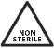 Non-sterile - Sterilize prior to use  Consult instructions for use
 US Federal Law restricts this device to sale by or on the order of a physician only.

 Product complies with requirements of directive 93/42/EEC for medical devices

CAUTION
Federal (USA) law restricts this device to sale by or on the order of a physician.

NOTE: IT IS THE RESPONSIBILITY OF THE REPROCESSOR TO ENSURE THAT THE REPROCESSING IS ACTUALLY PERFORMED USING EQUIPMENT, MATERIALS AND PERSONNEL IN THE REPROCESSING FACILITY TO ACHIEVE THE DESIRED RESULT. THIS REQUIRES VALIDATION AND ROUTINE MONITORING OF THE PROCESS. LIKEWISE, ANY DEVIATION BY THE REPROCESSOR FROM THE INSTRUCTIONS PROVIDED MUST BE PROPERLY EVALUATED FOR EFFECTIVENESS AND POTENTIAL ADVERSE CONSEQUENCES.

References
Lind, Natalie, Jack D. Ninemeier, and Bruce T. Bird. "High Temperature Sterilization." Central Service Technical Manual. Chicago, IL: International Association of Healthcare Central Service Materiel Management, 2007. 285-328. Print.A.A.M.I. Standards and Recommended Practice, “Safe Handling and Biological Decontamination of Medical Devices in Health Care Facilities and in Non-Clinical Settings”, ANSI/AAMI ST35:2003.

Sterilization for the Healthcare Facility, 2nd Edition, Reichert, M.; Young, J., “Wet Pack Problem Solving”, Lee, S. (Frederick, MD: Aspen, 1997).

AAMI Standards and Recommended Practices, “Steam Sterilization and Sterility Assurance in Health Care Facilities”, ANSI/AAMI ST46:2002;

“Flash Sterilization Steam Sterilization of Patient Care Items for Immediate Use, ANSI/AAMI ST37:3ed. AAMI

F.D.A. (21 CFR PART 58) and Good Laboratory Practice Regulations (G.L.P.) CDC Guideline for Disinfection and Sterilization in Healthcare Facilities, 2008
Jack D. Ninemeier, and Bruce T. Bird. "Low Temperature Sterilization." Central Service Technical Manual. Chicago, IL: International Association of Healthcare Central Service Materiel Management, 2007. 329-342. Print.

